Kol Simcha Torah Gazette
For succos 5787
Vol 11 Issue 3 (Whole #514) Tishrei 15-23 5787/ September 26-October 4, 2026
Printed L’illuy nishmas Nechama bas R’ Noach, a”h
For a free subscription, please forward your request to keren18@juno.com
Past emails can be found on the website ShabbosStories.com under Brooklyn Torah Gazette
A Royal Gift

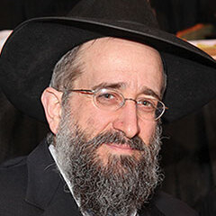
Rabbi Yisroel Reisman

Rav Yisroel Reisman once related the following story, which happened to someone on the west side of Manhattan, and it gives an incredible insight into the requests we ask of Hashem. A wealthy, Jewish individual who lives in one of the tall, prestigious buildings on the west side, was one day going down the elevator of his building.
There was someone else in the elevator with him, and he asked the other fellow why there were so many police cars in front of the building that day. The fellow answered him that he lives in the penthouse of the building, and he is the son of the king of Morocco, and he is a prince. He explained that his father, the king of Morocco was visiting America, and he also came to visit his son that day, and that was why there was a police presence outside the building.
The man couldn’t believe what he heard, and the prince asked him if he would like to meet his father, the king, and the man said that of course he would. It is no small thing to meet a king, as there is a Brachah to recite over it. The prince told this man to come over that night at eight o’clock to meet him.
This man happened to have had a son who had just become Bar Mitzvah, and he took his son along with him to meet the king. They went up to the penthouse, were escorted inside, and they met the king of Morocco and spoke with him for a few minutes. The king was very moved by the Bar Mitzvah Bochur, and he asked him a few questions. He asked him how old he was, and the boy answered that he was 13. The king said that he knew that 13 is a special age for a Jewish boy, and the boy said, “Yes, I was just Bar Mitzvah. I am going to Eretz Yisroel to see the Gedolim there and Daven there. It is a week after my Bar Mitzvah.” The visit ended shortly after that, and it was very pleasant.
The next day, this man went to his mailbox to get the mail, and he found that the king had left a check for the Bar Mitzvah boy as a gift. He was completely stunned when he saw that it was written out for $50,000! The father was very embarrassed and he went straight back up to see the prince. He thanked him for the gift, and he said, “I don’t know what you think the Jews do for Bar Mitzvah presents. Some people give $180, some will give $360, but we don’t give $50,000 gifts to Bar Mitzvah Bochurim.” The prince smiled and said to him, “You don't understand. Bar Mitzvah boys may get $180 gifts, but for the king of Morocco, it is inappropriate to give a gift of anything less than $50,000.”

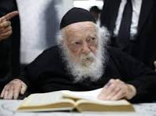
Rav Chaim Kanievsky

This father then went with his son on their trip to Eretz Yisroel, and when he was by Rav Chaim Kanievsky, zt”l, he told him what happened with the king of Morocco. Rav Chaim said to him, “Now I understand.”
The father was confused and asked what the Rav had understood. Rav Chaim explained, “We say during the Yomim Nora’im, Avinu Malkeinu Asei Lemancha V’lo Lema’aneinu, ‘Our Father, our King, act for Your sake and not for ours!’
Why do we say this? Do we really care if Hashem acts for His Own sake or for ours? What do we mean when we say this?” Rav Chaim said, “We only deserve $180 gifts, but for the Ribono
Shel Olam, the King of the world, it is not appropriate to give a less fitting gift. Hashem gives Royal Gifts! That’s what we mean when we ask Hashem to give for His sake, that Hashem should give us as is fitting for the King to give a gift, not merely for our sake, or on our level!”
Rabbi Reisman concluded, “Let’s take these words and not limit what we ask for, because Hashem is listening in these days of mercy, where our Tefilos and requests are answered, and we can ask Hashem for everything because Hashem does everything for us!”

Reprinted from the 5787 Yom Kippur email of Rabbi Yehuda Winzelberg’s Torah U’Tefilah.

Why Isn’t the Festival of Sukkah Named After Another Mitzvah
From the Teachings of the Lubavitcher Rebbe
Rabbi Menachem Mendel Schneerson, Zt”l
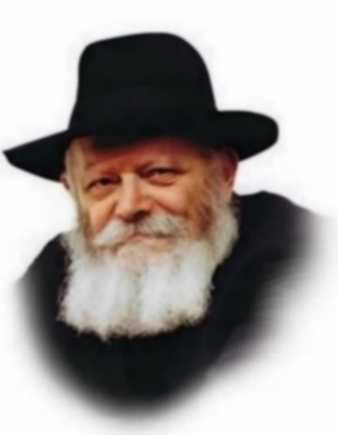
There are a number of mitzvot (commandments) performed on the festival of Sukot. We sit in the suka and partake of holiday meals there. We bring together four species of plants (two of which are the lulav and etrog) and make a blessing on them each day of the festival (except Shabbat). We say additional prayers and fulfill special customs. And yet, the festival is called "Sukot," after the temporary booths we dwell in during the holiday. Why doesn't the Torah call the festival "lulav" or "etrog," or choose a name for the holiday after another mitzva connected to our celebration of Sukot?
The mitzva of suka has a virtue not shared by any other mitzva of the holiday. The obligation to sit in the suka begins immediately when it gets dark on the very first night of Sukot, whereas the mitzva of the Four Species - taking an etrog, lulav, myrtle and willow branches and making a blessing over them - is not done until the following morning.
Another characteristic of the suka is that it must be prepared ahead of time. The walls of the suka must be built with the specific intent to perform the mitzva, and the suka may not be erected once the holiday itself has begun. In fact, building the suka is considered to be part of the mitzva as well. The Four Species, on the other hand, can be readied on the holiday itself and their procurement is not part of the mitzva.
Another advantage that the mitzva of suka has over the Four Species is the fact that one can perform it at any time of the day or night, and its obligation continues even after one has sat in it. Unlike the taking of the lulav and etrog, a person can never say that he has already performed the mitzva of suka, and he needn't enter once again that day! The suka is considered our temporary dwelling for the entirety of the festival, and we eat, drink, read, study and relax in it just as we would our own home.
But perhaps the most salient characteristic of the mitzva of suka is the fact that it is unlike any other in its encompassing nature. Other mitzvot are performed with a particular limb of the body pertaining to that mitzva, such as tefilin, which are placed on the arm and head. The mitzva of suka, however, totally envelops the person and is done with the entire body. The very same activities that were done in the house a week previously are elevated when done in the suka.
Our Sages said that a person who has no home "is not a person"; that is, he is not complete and whole without a place to live. The home affects the person not only when he is in it, but also when he is out in the marketplace and doing business as well. During the holiday of Sukot, our home is the suka, and it is through the performance of the mitzva that we reach our wholeness and perfection. Therefore, even when we are not physically inside the suka we remain connected to it once we have declared it to be our primary dwelling for the duration of the festival.

Reprinted from the 2003/5764 Parashat Succos edition of L’Chaim, a weekly publication of the Lubavitch Youth Organization.

Rav Avigdor Miller on
Justifying Misfortune (Part 2)

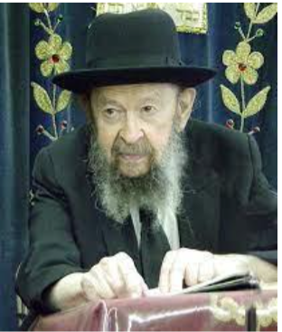

QUESTION: What kind of kindliness is that of Hashem to cause one father to suffer with a Mongoloid in order to give another father a chance to kvell in his normal child and even do some mitzvos to help Mongoloids?
ANSWER: What kindliness is it that one father should be tested by having a Mongoloid child whereas another one is able to rejoice in comparison with his children?
And the answer is everybody has something in this world. Nobody is perfect with all blessings in life. אדם לעמל יולד. (Iyov 5:7). A man is born for some kind of—I don’t want to say ‘suffering’—for some kind of difficulty. Everybody has difficulties in life. Here’s a man who has normal children but this man is a failure. He is such a failure that they have to have charitable organizations that send him chicken and fish for Shabbos. That man is deprived of medical services. He’s too poor. Many things in life he doesn’t have. At least there’s a compensation that he has normal children. You want to deprive him of that too?



And therefore, sometimes a man has compensations for a Mongoloid child. Let’s say he has other children. There are cases where these people have very good children and therefore they have so much nachas from the other children that other people don’t have! And it’s more than compensation.
Now, let’s say for argument’s sake, that a man has both a Mongoloid child and he has no other children and he’s also a beggar and also he himself is ill; he has all the misfortunes. So, he himself now takes the same place as his child and whatever misfortunes are visited upon a man which are not his fault, he receives full compensation in the existence where it really counts.
The compensation of Olam Haba is the purpose of our existence. And therefore, when people come there all the questions find their answer.

Reprinted from a recent email of Toras Avigdor based on a question asked to Rav Avigdor Miller in September 1983.

Thoughts that Count for
Shemini Atzeres/Simchas Torah

Dancing on Simchat Torah
The blessings and forgiveness which we seek on the Days of Awe by beseeching the Alm-ghty through solemn prayer and earnest repentance, can be attained on Simchat Torah in a joyous vein, by dancing with the Torah. (Rabbi Yosef Yitzchak Schneersohn, previous Lubavitcher Rebbe)

Shemini Atzeret
Our Sages explain the reason for the holiday of Shemini Atzeret thus: After the Jewish people had already been together with G-d for the seven days of Sukot, G-d requested that they remain with Him for another day, as "Your separation is difficult for Me." This can be interpreted to mean "The separation between one Jew and another is difficult for Me." In order to be strengthened against this separation, the Jewish people should gather together on Shemini Atzeret amongst themselves, while their hearts are happy, and they will come to closeness, love and unity.
(Tzror Hachaim)

Reprinted from the Parshat 5763/2003 (Issue #789) email of L’Chaim, a publication of the Lubavitch Youth Organization in Brooklyn, NY.

Not Just a Record of
Dates and Events

HoRav Elchanan Wasserman z”l (Kovetz Maamarim 91), teaches that, as Yidden, we should study( and incorporate into our lives) the teachings of the Sifrei Tanach, Shas, Rambam, and the Shulchan Aruch. We should however, study one major “sefer” (or discipline). This is the book of history of Am Yisrael, not just a record of dates and events, but a delving into the hashkafah, Torah perspective, of our gedolei Yisrael, so that we are able to discern and learn from the way Hashem has guided our lives.
When we study the patterns of history, we are able to deduce what the ratzon Hashem is, what He wants from us, how He wants us to live, and what our purpose in this world is. One of the areas of Jewish history that takes center stage is antisemitism. This scourge has accompanied us from the beginning of the Jew/gentile encounter, when Yaakov and Eisav were yet in the womb.
It concretized with Lavan and Yaakov and came to its prominence at Har Sinai, she’misham yardah sinaah, l’olam, “from our point” (from the moment that the Jew was singled out to be distinct from the nations,) sinah, hatred, enmity, descended to the world. No matter what our location, wherever we may live some form of sinah will be directed towards us.

The Proverbial Seventy Wolves
This is due to the fact that we are surrounded by the proverbial seventy wolves (nations); regardless of our being a minority among the world’s minorities, we are Jewish and, as such, we are different. It is in the blood/instinct of the gentile that the Jew is someone to revile — some more, others less- and it has been shown time and again throughout the generations that antisemitism is part and parcel of the DNA of being an eino Yehudi.
Understandably, all types of people are in this world, but the Jew is distinct. For that reason, he has become the scapegoat of history-- theological hostility towards the Jewish people. Indeed, the Yaavetz writes that the greatest miracle — even greater than the splitting of the Red Sea — is the continued existence of the Jewish people; despite the pogroms, exiles, and holocausts.

An Undeniable, Underlying
Pattern of Anti-Jewish Sentiment
If we take a short journey through history to the earliest periods in which society was somewhat civil, we see an undeniable, underlying pattern that has characterized anti-Jewish sentiment. [This, of course, skims over the periods of the early Catholic Church, in which the Jews were reviled for the “murder” of their savior. This led to the Crusades and Martin Luther’s rabid loathing, which laid the foundation and became the backdrop of the Nazi doctrine.]
Following the French Revolution which resulted in European Emancipation, the walls of the Jewish ghetto came tumbling down, and Jews were granted equal rights. Along with this newfound freedom/equality, the Haskalah, Enlightenment movement, arose. The Haskalah was the forerunner of the secular Jewish streams and “isms” which preached that, as long we appear and act different from our gentile counterparts, they will hate us.
Thus, they sanctioned eschewing Jewish observance and aligning with the goyim in their depraved culture. Once and for all, be and act like a goy. This theory almost destroyed all of German Jewry, as thousands drank from the baptismal font during the nineteenth century.
Sadly, it was from Berlin that the greatest manifestation of antisemitism, the Holocaust, emerged. The Russians with their versions of Enlightenment, Communism, Bundism, and Yiddishist succeeded in assimilating more Jews, but were unable to curb the gentile’s appetite for murdering Jews. This was followed by the secular Zionists, whose manifesto was that, as long as the Jews did not have a land they could call their own, we would not achieve the respect of the world. Apparently, that did not work out very well either.

Either We Belong to Hashem
or We Belong to the Goyim
Am Yisrael is an am kadosh, holy nation, who is to remain distinct in everything we do. We are guided by the Torah, which is our lodestar for living — both physically and spiritually, since everything in life falls under the rubric of the spirit. Either we belong to Hashem or we belong to the goyim. This has been proven time and again.
As the Bais Halevi famously said, “When the Yid does not make Kiddush (sanctify himself, being distinct in his beliefs and behavior), the goy will make Havdalah, separation. (They will see to it that we are disconnected and excluded from them.) The Kelmer Maggid declared that, while the German Reform Movement sanctioned intermarriage as a means to gain acceptance in the eyes of the gentile community, years later, an edict went forth from Berlin (Nazi government) prohibiting Germans from marrying Jews.

Anti-Semitism Has Painfully Saved
Us From Total Assimilation
This has been the painful paradox, the irony that has shadowed us through our history: when we attempt to gravitate to the goyim, to assimilate into their culture, their innate hatred emerges to remind us of our Jewish identity. When the world rejects us, we gravitate back home to our people- to Hashem. Indeed, antisemitism has painfully saved us from total assimilation.
The lesson to be derived: If they continue to hate us, it is an indication that we are still “us,” Jews. No exit strategy from Judaism exists. This has been the pattern that has followed us through history. In Medieval Spain, the Jews rose to power and prestige - the assimilation that followed was the precursor to the Inquisition.
In nineteenth-century Western Europe and especially Germany, assimilation was rampant. We know what followed. Even in the twenty-first century, a time in which Jews attempt to shed their identities, they are painfully reminded by terror attacks, campus hate, and politicians whose shameless crude remarks against us have no parameters.
At times, however, the worst attacks can spark powerful reminders. Mark was a secular Jew who, in 1999, lived in a quiet neighborhood in Sacramento, California. He lived near a synagogue, but, as an assimilated Jew who had married out, even a secular synagogue was an anomaly to him. He was not interested in his biological Jewish background, because, as a "liberated" Jew, it meant nothing to him.

A Legacy of the Two White Supremacists
Then, two white supremacists, brothers for whom hatred of Jews was their unifying cause in life, firebombed the synagogue, causing serious damage. This was repeated in two other synagogues. [The religious leanings of these edifices has no bearing on the story, because, to Mark, even the most left-leaning synagogue was distant from him, since, in his mind, he had severed his relationship with Judaism]
The near-tragedy changed his life. He attended a vigil, where a young rabbi asked him whether he wanted to do something meaningful, like put on Tefillin. This led to Shabbos observance, kashrus and Torah study. The fire that was to burn down his identity, instead kindled a dormant spark in his neshamah until he no longer ran from his heritage. Hatred hurts — but it preserves.

Reprinted from the Parshas Ha’azinu 5786 email of Peninim on the Torah.

What Is an Etrog?
By Menachem Posner

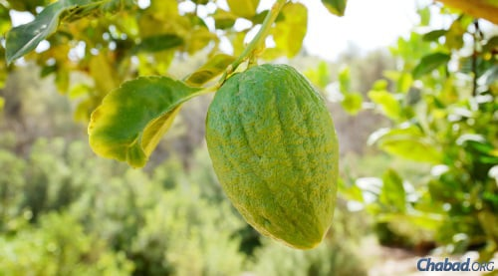
An etrog growing in Israel (file photo).
What Is a Lulav and Etrog Set?
An etrog (אֶתְרוֹג, also pronounced "esrog") is a yellow (or lime-colored) citrus fruit used by Jews during the week-long holiday of Sukkot as one of the Four Species. It is also known as a citron or a citrus medica.
Every day of Sukkot, except for Shabbat, the etrog is taken in hand together with a bundle containing a lulav (palm frond), three hadassim (myrtles) and two aravot (willows) waved in each direction.

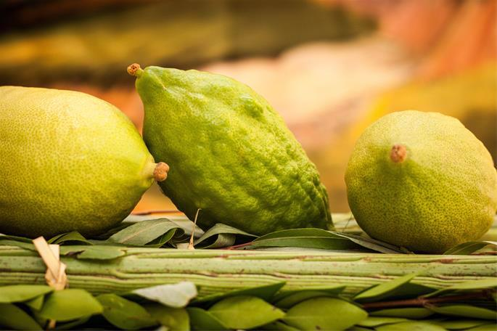

The Identity of the Etrog
There are several varieties of etrog used by Jews today, each of which has been carefully identified by successive generations of Jews. There are etrogim from Yemen, the types grown in Israel, and the variety from the Calabria region of Italy, which are favored by many. The Calabrian variety is unique in that by the time it matures, it often does not have the distinctive pitom on its snout.

The Hadar Fruit
The Torah¹ describes the fruit which we must take as פרי עץ הדר—pri etz hadar, which translates loosely as the “fruit of a tree which is hadar.” What is hadar?
Since the days of Moses, we have known this to be an etrog. There was never a time when the identity of the fruit needed was in doubt. Rather, each generation told the next generation which fruit was needed to complete the Four Kinds.² Nevertheless, various propositions were made to demonstrate that this can also be understood from the text.
The common meaning of הדר hadar is “beautiful.” Ibn Ezra³ writes that the etrog is known as the most beautiful of all fruits, and when the Torah tells us to take a beautiful fruit, the only possible candidate is the etrog.
Alternatively, Nachmanides⁴ writes that hadar is actually the ancient Hebrew name for the etrog, the latter being its Aramaic name. Hence the verse is simply telling us to take the fruit of the etrog tree.

The Etrog in the Talmud
The sages of the Talmud,⁵ knowing that this term referred to the etrog, found a number of creative ways of seeing the etrog’s distinct properties in the above-mentioned verse:
Focusing on the first two words of the description, “fruit of a tree,” the Talmud understands this to refer to a tree that tastes similar to to its fruit. The wood of the etrog tree is similar in taste to its fruit.
Rabbi Judah the Prince points out that the word הדר hadar can also be rendered as הדיר hadir—a sheep pen. Just as a pen has both old and young animals, so does the tree in question have old and young fruit at the same time. This refers to the etrog tree, whose fruit continues to grow through all seasons, allowing for a single etrog tree to simultaneously hold fruits in multiple stages of growth.
Rabbi Abahu suggests that hadar can also mean “the resident.” This means that this is the fruit which is a resident on its tree—referring to the etrog’s prodigally long growth period.
Ben Azzai said that hadar is etymologically related to the Greek hydor (water)—from which the English word “hydration” is derived. This is a reference to the fact that the etrog tree needs a lot more water than other trees.
As I wrote, all of these suggestions are purely academic, since we have known since the Giving of the Torah that the fruit which we needed to take is the etrog.

Footnotes
1. Leviticus 23:40. 2. Maimonides, Commentary to the Mishnah, Introduction to Seder Zeraim.
3. Ibn Ezra, commentary to Leviticus ibid. 4. Nachmanides, commentary to Leviticus ibid.
5. Talmud, Sukkah 35a.

Reprinted from the Chabad.Org website.
An Exquisite Gilded
Torah Shield

- 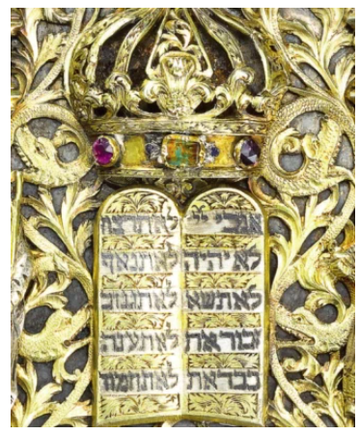

This Sassoon 18th-century Torah shield represents the artistry of a remarkable Jewish goldsmith and the connoisseurship of the well-known family. This exquisite example from the Sassoon collection is crafted from partially gilded silver, enamel and gems. This item was sold in a Sotheby Judaica Auction.
An Esrog Before
Being Harvested

